1) Counting Even and odd entries

// Counting Even and odd entries
#include<iostream.h>
#include<conio.h>
main()
{
clrscr();
int a[10],odd=0,even=0;
for(int i=0;i<10;i++)
{
cout<<"\n\n Enter a number ";
cin>>a[i];
if (a[i]%2==0)
even++;
else
odd++;

}
cout<<"\nThere are "<<even<<" even entries";
cout<<"\nThere are "<<odd<<" odd entries";
getch();
}

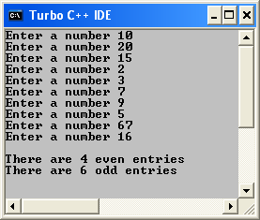

2) Printing Percentage and sum marks

// Printing Percentage and sum marks
#include<iostream.h>
#include<conio.h>
main()
{
clrscr();
int a[5],sum=0;
for(int i=0;i<5;i++)
{
cout<<"\n\n Enter marks ";
cin>>a[i];
sum=sum+a[i];

}
cout<<"\nThe total mark is "<<sum;
cout<<"\nThe percentage is "<<sum/5;
getch();
}

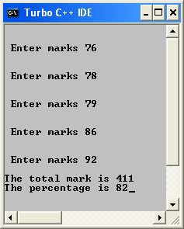

3) Checking if Salary is more than one lakh

// Checking if Salary is more than one lakh
#include<iostream.h>
#include<conio.h>
main()
{
clrscr();
long unsigned int a[10];
for(int i=0,flag=1,num=0;i<10;i++,flag++)
{
cout<<"\n\n Enter the monthly salary of employee number "<<flag<<" ";
cin>>a[i];
if (a[i]*12>=100000)
num++;
else
num=num;

}
cout<<"\nThere are "<<num<<" employees with salaries more than 1 lakh per annum";

getch();
}

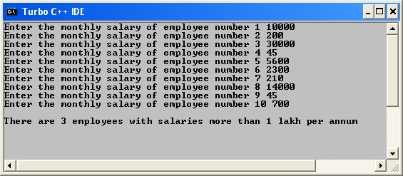

4) Printing the reverse
// Printing the reverse
#include<iostream.h>
#include<conio.h>
main()
{
clrscr();
int a[5];
for(int i=0;i<5;i++)
{
cout<<"Enter a number ";
cin>>a[i];
}
cout<<"\n\nThe Reverse is: \n\n";
for(int j=4;j>=0;j--)
cout<<a[j]<<endl;

getch();
}

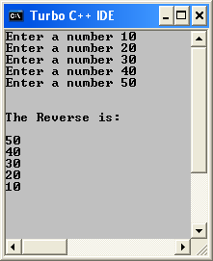

5) Printing and Storing the reverse
// Printing and Storing the reverse
#include<iostream.h>
#include<conio.h>
main()
{
clrscr();
int a[5],i=0,j=4;
for(;i<5;i++)
{
cout<<"Enter a number ";
cin>>a[i];
}

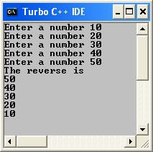

6) Calculating the maximum and minimum no.
// Calculating the maximum and minimum no.
#include<iostream.h>
#include<conio.h>
main()
{
clrscr();
int a[10],max=0,min=32767;
for(int i=0;i<10;i++)
{
cout<<"Enter a number ";
cin>>a[i];
if(a[i]>max)
max=a[i];

if(a[i]<min)
min=a[i];
}
cout<<"\n\n\nThe largest number is "<<max;
cout<<"\n\n\nThe smallest number is "<<min;
getch();
}
